EX NO: 5 | Implementation of an IoT-Based Smart Home Automation Network Using Cisco Packet Tracer
DATE:08/08/26

Objectives
- To design and configure an IoT smart home network with PC-based monitoring and control, integrating IoT devices, an access point, a switch, and an IoT server to enable centralized management of smart appliances.
- To establish smartphone-based Wi-Fi connectivity for remote access and control of IoT devices, and verify wireless communication between the mobile device and the smart home network through the access point and IoT server.

Software/Apparatus required:
- Cisco Packet Tracer
- End Devices (PCs)
- Switches
- Copper Straight-through Cable / Automatic Cable Selector
- Routers
- Server (DHCP)
- Household devices (Fan, AC, Light, Garage door)

Procedure:
Objective 1: PC based monitoring
  - Open Cisco Packet Tracer and create a new workspace.
  - Add a Home Gateway/Access Point, Switch, Server, PC, and IoT devices (Fan, Air Conditioner, Garage Door, and Light).
  - Connect the Server and Home Gateway to the Switch using copper straight-through cables.
  - Configure IP addressing for the Server and PC.

  - Enable IoT services on the Server and create a user account.
  - Connect the IoT devices wirelessly to the Home Gateway.
  - Register all IoT devices with the IoT Server.
  - Verify that the devices appear in the IoT Server dashboard.
  - Access the IoT Server from the PC using a web browser.
  - Monitor and control the IoT devices through the PC interface and verify their operation. Objective 2: Smartphone-based monitoring
- Open the configured IoT smart home topology in Cisco Packet Tracer.
- Add a Smartphone and ensure the Home Gateway/Access Point is active.
- Configure the wireless network (SSID and password) on the Home Gateway.
- Connect the Smartphone to the Wi-Fi network using the configured SSID.
- Ensure the Smartphone obtains an IP address automatically.
- Open the IoT monitoring application or web browser on the Smartphone.
- Log in to the IoT Server using the registered user credentials.
- Access the list of connected IoT devices.
- Remotely monitor and control the Fan, Air Conditioner, Garage Door, and Light using the Smartphone.
- Verify that the device status changes according to the commands issued from the Smartphone.
Objective 1: PC based monitoring

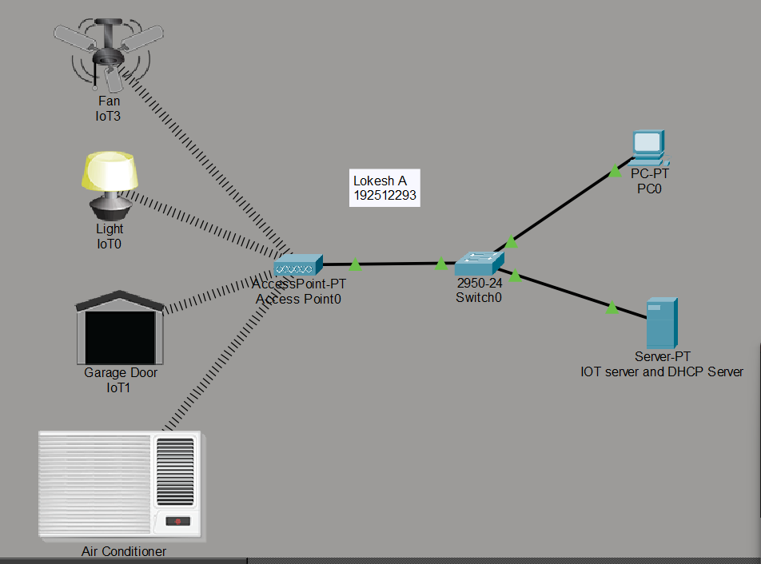

Objective 2: Smart phone based monitoring

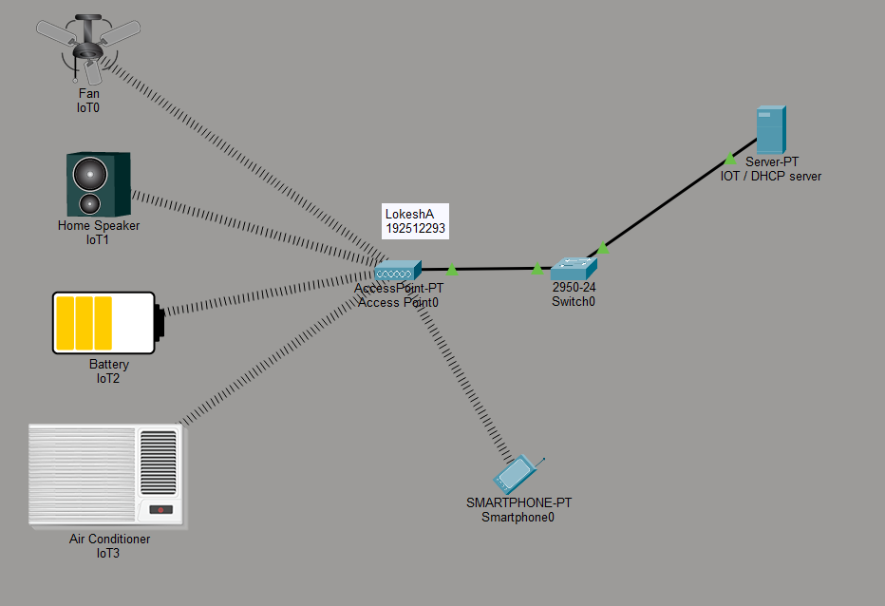

Objective 1: PC based monitoring

Things | Default | Control
Fan | Off | ON
AC | Off | ON
Garage Door | Open | CLOSED
Light | Dim | BRIGHT

Objective 2: Smart phone based monitoring

Things | Default | Control
Fan | Off | ON
AC | Off | ON
Garage Door | Open | CLOSED

Light | Dim

Result
Objective 1: PC based monitoring
The IoT smart home network was successfully configured, and the PC was able to monitor and control the connected IoT devices through the server.
Objective 2: Smart phone based monitoring
The smartphone was successfully connected to the Wi-Fi network and was able to remotely monitor and control the IoT devices.

Test Case Question 1
Implement the specified IoT Smart Home topology using Cisco Packet Tracer and analyze PC-based monitoring and control of IoT devices through an IoT server.
Case 1
- Number of PCs: 1
- Number of Switches: 1
- Number of Home Gateways/Access Points: 1
- Number of IoT Servers: 1
- Number of IoT Devices: 4 (Fan, Air Conditioner, Garage Door, Light)
- Access Method: PC-Based Monitoring Case 2
- Number of PCs: 2
- Number of Switches: 1
- Number of Home Gateways/Access Points: 1
- Number of IoT Servers: 1
- Number of IoT Devices: 6 (Fan, Air Conditioner, Garage Door, Light, Webcam, Smoke Detector)
- Access Method: PC-Based Monitoring Tasks
- Construct the specified topology and configure the IoT server and home gateway.
- Register the IoT devices with the IoT server and establish network connectivity.
- Access the IoT server from the PC and verify monitoring and control of all IoT devices.

Test Case Question 2
Implement the specified IoT Smart Home topology using Cisco Packet Tracer and analyze smartphone-based Wi-Fi monitoring and control of IoT devices.
Case 1
  - Number of Smartphones: 1
  - Number of Switches: 1
  - Number of Home Gateways/Access Points: 1
  - Number of IoT Servers: 1

  - Number of IoT Devices: 4 (Fan, Air Conditioner, Garage Door, Light)
  - Access Method: Mobile Wi-Fi Control Case 2
  - Number of Smartphones: 2
  - Number of Switches: 1
  - Number of Home Gateways/Access Points: 1
  - Number of IoT Servers: 1
  - Number of IoT Devices: 6 (Fan, Air Conditioner, Garage Door, Light, Webcam, Smoke Detector)
  - Access Method: Mobile Wi-Fi Control
  - Wireless Network: Secured Wi-Fi Connection Tasks
- Construct the specified topology and configure the IoT server, home gateway, and Wi-Fi settings.
- Connect the smartphones to the wireless network and register the IoT devices with the server.
- Access the IoT server from the smartphones and verify remote monitoring and control of all IoT devices

